Name of the laser manufacturer:

Model name of the Laser:

Please send back to:
+49.(0)911.97 36-8199
Or by e-mail:
info@lvg.com
"We collect, store and use your data exclusively to process your request. For more information, please see our data privacy. "
Company
Contact person
Street
Area code / City
Phone
Fax
E-mail-address

Please send me a free quotation for: eyewear windows curtains

 | Full protection acc. to EN 207: |  | I need separate glasses for all lasers
 | Alignment protection acc. EN 208 (only with lasers in the visible range 400 – 700 nm) |  | I need to have one pair of glasses for all lasers

Laser specifications: | Laser 1 | Laser 2  (if applicable) | Laser 3  (if applicable) | Dimension units
Laser wavelength |  |  |  | nm
Max. average power |  |  |  | W | Hz
Smallest accessible beam diameter |  |  |  | mm
Smallest beam divergence or M² |  |  |  | mrad  (half angle)
Max. pulse energy |  |  |  | J | Hz
Max. pulse repetition rate |  |  |  | Hz | J
Shortest pulse length |  |  |  | s

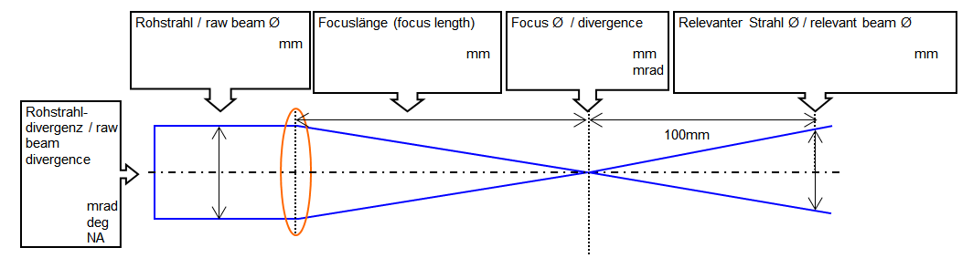

Please send me free information material on EYEPRO: Software to calculate the proper scale numbers
acc. to EN 207/208/60825)

